Git Challenges
- Resolve Merge Conflicts
  - Create a merge conflict intentionally (two users editing the same line).
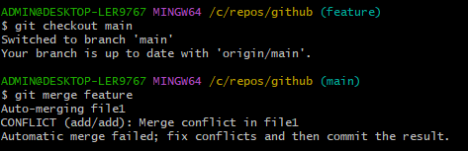
  - Resolve the conflict and push the changes.
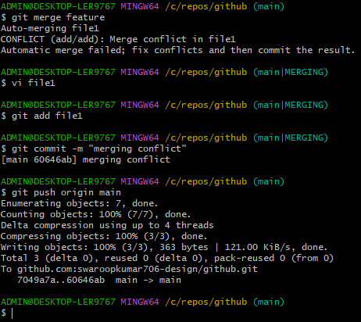
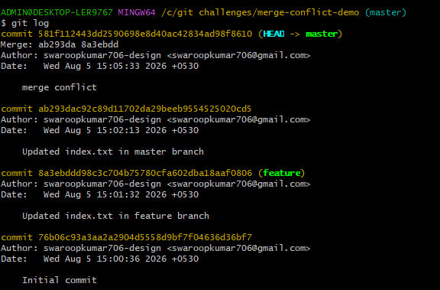
- Recover Deleted Branch
  - Delete a local branch and then recover it using the reflog.
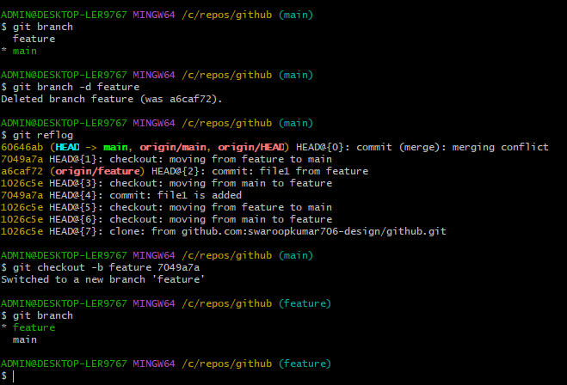
- Undo Wrong Push
  - Push a wrong commit to GitHub, then undo it without losing history.
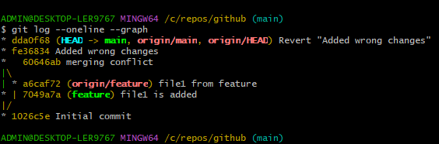
- Amend a Commit
  - Make a commit, then add a missing file to it usinggit commit --amend.
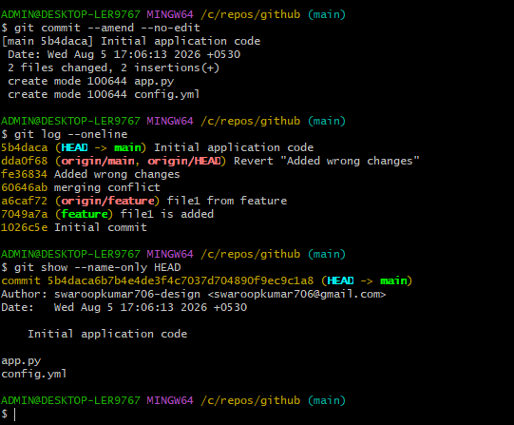
- Cherry-pick a Commit
  - Take a specific commit from one branch and apply it to another branch.
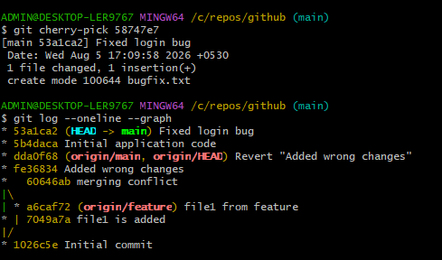
- Interactive Rebase
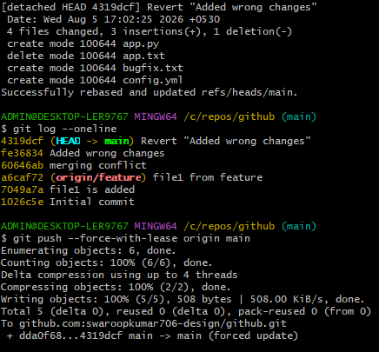
- Tagging & Release
  - Create a version tag (v1.0), push it to GitHub, then delete and restore it.
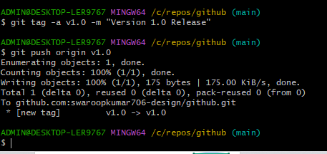
- Clone with Sparse Checkout
  - Clone only a subdirectory of a repo using sparse checkout.
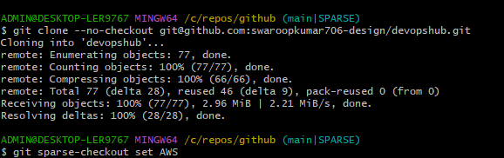
- Reset vs Revert Challenge
  - Demonstrate the difference betweengit reset --hardandgit revertin a repo.
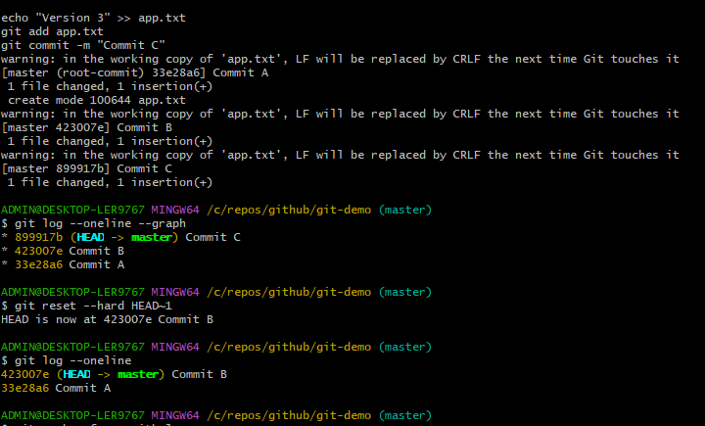
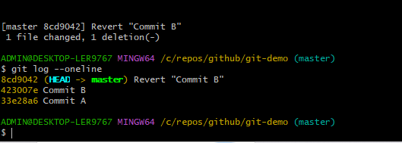
- Detached HEAD Challenge
  - Checkout a specific commit (detached HEAD state) and create a new branch from it.
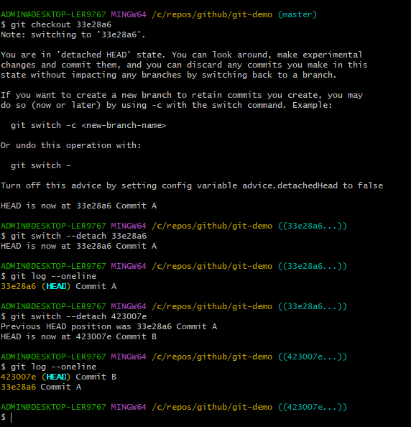
- Git Hooks Challenge
  - Configure apre-commithook to reject commits without a message format (e.g., must start withJIRA-XXX).
- Squash Merge vs Rebase Merge
  - Show the difference between squash merge and rebase merge with evidence.
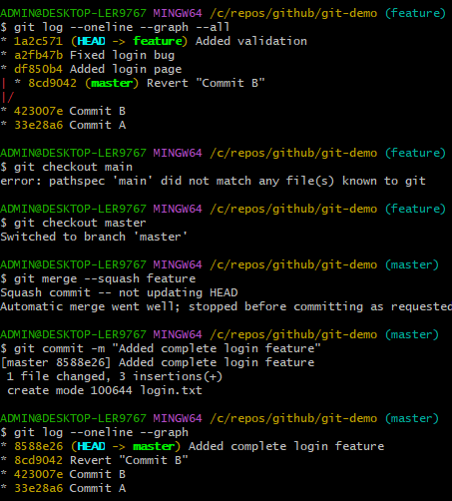
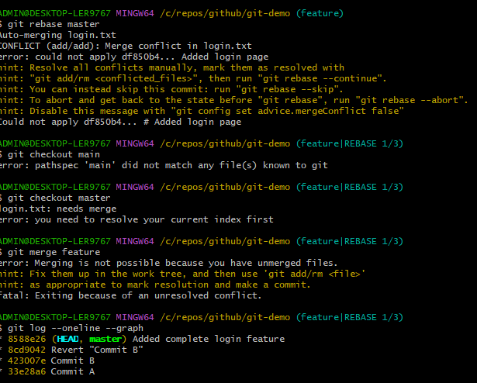
- Fork & Pull Request Workflow
  - Fork a repo, make a change, and submit a pull request to the original repo.
Fork a GitHub repository.
Clone your fork locally.
Create a new branch.
Make changes and push them.
Submit a Pull Request (PR) to the original repository.

- Recover Lost Commit
  - Commit something, reset hard, and then recover it usinggit reflog.
